Guidelines and Samples for Abstracts and Posters

This Guideline consists of 5 pages including this cover.
- Guideline for Abstracts
- Sample Abstract 1
- Sample Abstract 2
- Guideline for Posters

Guideline for Abstracts

Abstract Title (Times New Roman, bold, 11 pt. font)
(Space)
Author Names (Times New Roman, 11 pt. font: First Name Initial Surname)
(Space)
Affiliation (Times New Roman, italics,11 pt., with e-mail of corresponding author)
(Space)
Abstract Text (250 words maximum, Justified, Times New Roman, 11 pt. font)

Sample Abstract 1

Clubroot in Canadian Canola (Brassica napus)

Sheau-Fang Hwang and Stephen E. Strelkov*

Department of Agricultural, Food and Nutritional Science, University of Alberta, Edmonton, Alberta, T6G 2P5 Canada
*Email: stephen.strelkov@ualberta.ca

Clubroot, caused by the obligate parasite Plasmodiophora brassicae, is a major disease of the Brassicaceae family. However, until a decade ago, clubroot had not been reported in Canadian canola (Brassica napus), a crop that contributes more than $15 billion annually to Canada’s economy. The identification of clubroot was a major cause for concern and stimulated significant research into this disease. Initially, the outbreak was confined to central Alberta, where 12 clubroot infested fields were identified in 2003. Continued surveying has shown that clubroot is spreading, and as of 2012 there were at least 1,064 fields with confirmed infestations. While most of these fields are located in central Alberta, isolated cases of clubroot have also been identified in southern Alberta and the neighboring province of Saskatchewan. P. brassicae inoculum has also been detected in a few fields in Manitoba. Most of the spread has resulted from the movement of infested soil on farm and other machinery, although other mechanisms of dissemination have also been implicated. Pathotype 3 of P. brassicae, as classified on the differentials of Williams, appears to be predominant on canola. Clubroot management strategies have focused largely on exclusion and sanitation, as well the cropping of clubroot-resistant canola cultivars, a number of which have been released since 2009. Genetic resistance will have to be well-managed, however, as the virulence of pathogen populations can shift as a consequence of the selection pressure imposed by the cropping of resistant cultivars.
Sample Abstract 2

The Effect of Inoculation Cymbidium kanran with Six Isolates of Orchid Mycorrhizal Fungi

Han-Kyeol Han¹, Yong-Chan Jo², Jaemin Chung², and Ahn-Heum Eom¹*

¹Department of Biology, Korea National University of Education
²Department of Plant Resources Conservation, Korea National Arboretum
*Email: eomah@knue.ac.kr

Orchid Mycorrhizal Fungi (OMF) has a symbiotic relationship with orchid plants by supplying nutrient like phosphate and nitrogen to orchid. In this study, 70 Cymbidium kanran were inoculated with 6 isolates of OMF isolated from roots of 5 species of wild orchids. 256 days after cultivating, biomass, dry weight and infection rate of C. kanran were measured. Biomass of group inoculated with 11Y061 isolated from Neolindleya camtschatica was heaviest. Dry weight was the heaviest when C. kanran were inoculated with 12O040 isolated from Goodyera schlechtendaliana. Infection rate was highest in a group inoculated with 11Y040 isolated from Cremastra variabilis.

Guideline for Posters

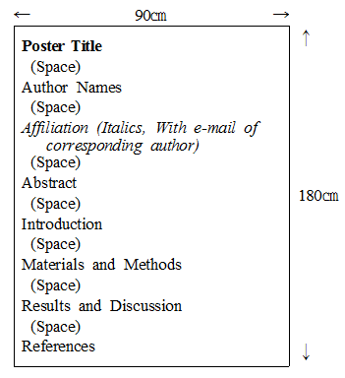

* There are no limits for character size and fonts in the posters.
* Poster Sizes: width 90cm × height 180cm

